**Year 11 Physics**

**Heating and Cooling**

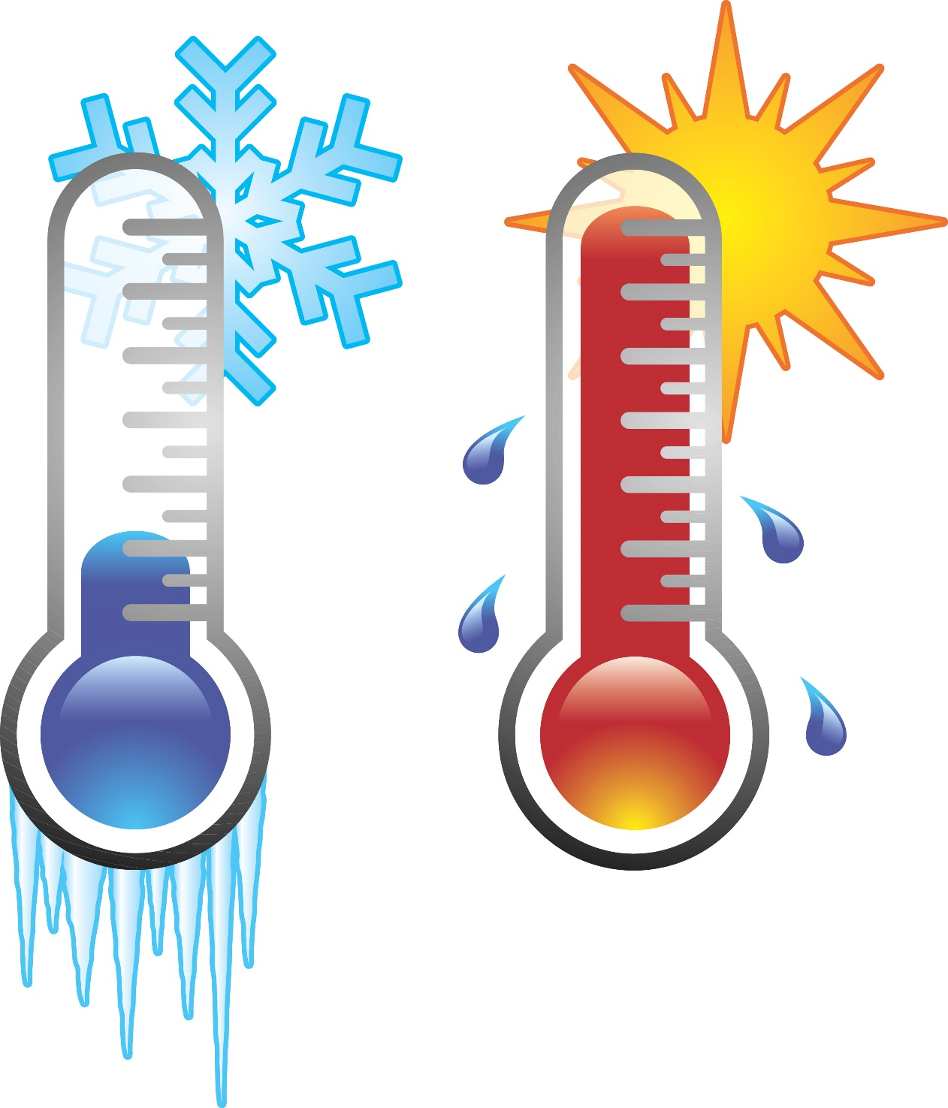

(Thermometer Clip Art - Image #8708, n.d.)

**Name:**

****Proposed timeline****

|  |  |  |  |  |  |
| --- | --- | --- | --- | --- | --- |
| **Wk** | **#** | **Topic** | **PowerPoint** | **STAWA Questions** | **Pearson Physics** |
| 2 | 1 | Heat vs Temperature, Temperature scales | 1-20 | Set 1 | 1.1 |
| 2 | 2 | Kinetic Theory | 1-20 | Set 1 | 1.1 |
| 2 | 3 | Internal Energy | 1-20 | Set 1 | 1.1 |
| 2 | 4 | **Task 1: Working Scientifically Analysis** |  |  |  |
| 2 | 5 | Power | 1-20 | Set 1 | 1.1 |
| 3 | 1 | Specific Heat Capacity | 21-36 | Set 3 | 1.2 |
| 3 | 2 | Method of Mixtures | 21-36 | Set 3 | 1.2 |
| 3 | 3 | Method of Mixtures | 21-36 | Set 3 | 1.2 |
| 3 | 4 | Cooling curves | 37-44 | Set 3 | 1.3 |
| 3 | 5 | Latent Heat | 37-44 | Set 3 | 1.3 |
| 4 | 1 | Method of Mixtures with Phase Changes | 37-44 | Set 3 | 1.3,1.4 |
| 4 | 2 | Method of Mixtures with Phase Changes | 37-44 | Set 3 | 1.3,1.4 |
| 4 | 3 | Conduction | 45-59 | Set 2 | 2.2 |
| 4 | 4 | **Task 2: Specific Heat Capacity of a Substance** |  |  |  |
| 4 | 5 | Convection | 45-59 | Set 2 | 2.3 |
| 5 | 1 | Labour Day |  |  |  |
| 5 | 2 | Radiation | 45-59 | Set 2 | 2.4 |
| 5 | 3 | Solar water heaters | 45-59 | Set 2 |  |
| 5 | 4 | Refrigerators | 45-59 | Set 2 |  |
| 5 | 5 | Vacuum flasks | 45-59 | Set 2 |  |
| 6 | 1 | House insulation | 45-59 | Set 2 |  |
| 6 | 2 | Revision |  |  |  |
| 6 | 3 | Revision |  |  |  |
| 6 | 4 | **Task 3: Thermal Physics Topic Test** |  |  |  |
| 6 | 5 | Working scientifically |  |  |  |

**SCSA ATAR Syllabus**

<https://senior-secondary.scsa.wa.edu.au/syllabus-and-support-materials/science/physics>

**Science Understanding**

* the kinetic particle model describes matter as consisting of particles in constant motion, except at absolute zero
* all substances have internal energy due to the motion and separation of their particles
* temperature is a measure of the average kinetic energy of particles in a system
* provided a substance does not change state, its temperature change is proportional to the amount of energy added to or removed from the substance; the constant of proportionality describes the heat capacity of the substance This includes applying the relationship
$$Q=mc∆T$$

* change of state involves separating particles which exert attractive forces on each other; latent heat is the energy required to be added to or removed from a system to change the state of the system This includes applying the relationship
$$Q=mL$$

* two systems in contact transfer energy between particles so that eventually the systems reach the same temperature; that is, they are in thermal equilibrium. This may involve changes of state as well as changes in temperature
* a system with thermal energy has the capacity to do mechanical work [to apply a force over a distance]; when work is done, the internal energy of the system changes
* because energy is conserved, the change in internal energy of a system is equal to the energy added by heating, or removed by cooling, plus the work done on or by the system
* heat transfer occurs between and within systems by conduction, convection and/or radiation
* energy transfers and transformations in mechanical systems always result in some heat loss to the environment, so that the usable energy is reduced and the system cannot be 100 percent efficient This includes applying the  
  relationship

$$efficiency η=\frac{energy output}{energy input}×100\%$$

**Science as a Human Endeavour**

The development of heating technologies that use conduction, convection, radiation and latent heat have had, and continue to have, significant social, economic and environmental impacts. These technologies include:

* passive solar design for heating and cooling of buildings
* the development of the refrigerator over time
* the use of the sun for heating water
* engine cooling systems in cars.

****Fundamental Concepts****

* Temperature: a measure of the average particle kinetic energy of a substance
* Particle kinetic energy: the kinetic energy associated with the small scale random vibration/movement of particles
* Internal energy: the sum of particle kinetic energy and potential energy held by a substance
* Heat: the flow of internal energy from one object to another to achieve thermal equilibrium (from a higher temperature object to a lower temperature object)
* Thermal Equilibrium: two objects are in thermal equilibrium if they are at the same temperature i.e. if there is no net flow of energy between them
* Our bodies are not sensitive to temperature as such, they detect the flow of energy in to or out of them

****Temperature Scales****

|  |  |
| --- | --- |
| ****Celsius**** | ****Kelvin**** |
|  |  |
|  |  |
|  |  |

****Kinetic Theory assumptions****

* All matter is made of many very small particles (atoms or molecules)
* Particles are in constant motion
* Forces of attraction and repulsion exist between the particles, potential energy is stored in the intermolecular bonds (springs)
* The distance between particles in a gas is very large compared to the size of the particles
* Collision between particles and with the walls of the container are perfectly elastic (no loss of EK)

****States of matter****

|  |  |  |
| --- | --- | --- |
| ****Solid**** | ****Liquid**** | ****Gas**** |
|  |  |  |
|  |  |  |

****Compression and expansion of gases****

* **When a gas is compressed the atoms move closer together losing EP, becoming EK so temperature increases**
* **When a gas undergoes expansion, the atoms spread further apart gaining EP so EK decreases lowering T**

****Absolute zero****

* At absolute zero particles have 0 EK
* Any gas reduced to absolute zero exerts zero pressure on its surroundings
* Particles cease moving completely

****Thermal expansion****

* As a substance is heated it gains thermal (kinetic) energy as the particles vibrate/move faster
* It also gains potential energy as the faster moving particles stretch the bonds between particles moving further apart
* As the particles all move slightly further apart the substance expands

****Conservation of energy****

* Energy can neither be created nor destroyed.
* Energy can be transferred or transformed but the total energy of an isolated system remains constant.
* Net change in energy is 0.

****Internal energy****

* The energy contained within a system
* It excludes the kinetic energy of motion of the system as a whole and the potential energy of the system as a whole due to external force fields.
* ∆U rather than absolute values
* Mostly represents the sum of thermal energy of a substance and the potential energy stored in stretched bonds in the substance

$$∆U=Q_{in}-Q_{out}-W_{by}+W_{on}$$

Qin = heat flow into the system

Qout = heat flow out of the system

Wby = work done by the system

Won = work done on the system

A 1l beaker of water has 25 k J of work done on it and also loses 30 k J of thermal energy to the surroundings. Determine the change in energy of the water.

A heating element in a paddle-wheel apparatus deliver 2530 J of energy to the water and the paddle does 240 J of work on the water. Calculate the change in internal energy of the water.

****Power****

* Rate of energy transfer/transformation.
* Rate of work.
* Joules/second or Watts
$$P=\frac{W}{t}=\frac{∆E}{t}$$

* Often applied in conjunction with efficiency

$$efficiency η=\frac{energy output}{energy input}×100\%$$

A car produces 570 kJ of energy from combusting petrol with air. Only 190 kJ of useful mechanical energy was delivered by the car.

1. Show the energy transformation as a flow diagram.
2. What is the car’s efficiency?

Determine the amount of light energy delivered by a 60 W incandescent globe that is switched on for 45 minutes. The efficiency of the globe is 3.0%

****Specific heat capacity****

* Specific to a substance
* Amount of energy required to raise the heat of 1 kg of the substance by 1 degree (C or K)
* Highest element: c(H2(g)) = 14300 J kg-1 K-1
* Lowest element: c(Tc(s)) = 63 J kg-1 K-1

ΔQ = change in energy, energy gained/lost (J)

m = mass (kg)

c = specific heat capacity (J kg-1 K-1)

ΔT = change in temperature (K or ◦C)

Tf = final temperature (K or ◦C)

Ti = initial temperature (K or ◦C)

2000g of water at 20 $℃$ has a 2kW immersion heater placed in it for 2 minutes. Determine final temperature.

The two disk brakes of a 600 kg motorbike each have a mass of 1 kg. The motorbike brakes to a stop from a velocity of 30 m s-1. If 50 % of the bikes EK is transferred to the brakes; calculate their rise in T (c = 500 J kg-1 K-1)

How much heat is required to raise the temperature of an empty 20kg vat made of iron from 100C to 900C? (ciron=450 J kg-1 K-1)

What if the vat was filled with 20kg water?

****Water- high specific heat capacity****

* Water has notably high specific heat capacity
* Takes a long time to heat up also takes a long time to cool down
* Has to absorb a lot of energy to heat up also has to release a lot of energy to cool down
* The British Isles are warmer than they should be at their latitude
* Caused by warm currents flowing up from the equator known as the Gulf Stream
* Large amounts of energy transferred by the water

****Water cooling systems****

* Any many machines water is used as the coolant (with some additives)
* Pumped over hot elements to absorb energy from them then through a component designed to cool the water (e.g. car radiator)
* High c so water would have to absorb an enormous amount of energy to boil in the pipes
* Can store and transfer large amounts of energy without undergoing phase change

****Hot food****

* Why is the filling of a pie so much more dangerous than the crust?
* Filling has high water content, which has a high specific heat capacity so it stores a lot of energy and releases a lot as it cools
* Crust has little water and a lot of air so it cools down quickly, not having stored a lot of energy
* Additionally, pastry insulates the filling preventing heat loss to surroundings

****Onshore/offshore winds****

* During the day, land heats faster than the sea, heats air above it, creating convection currents
* Caused by lower specific heat capacity of the land, assuming land and sea receive same energy input, land will increase in temperature more
* At night land cools faster than sea, warmer sea keeps air above warmer creating convection currents
* Caused by higher specific heat capacity of water, sea stores more energy to release and cools more slowly

****Method of mixtures****

* Can be used to determine specific heat capacity of unknown substances
* Combine 2 objects, ensure all heat lost by one object is gained by the other:
$$Q_{lost}=Q_{gained}$$

$$m_{1}c_{1}{∆T}_{1}=m_{2}c_{2}{∆T}_{2}$$

$$m_{1}c_{1}(T_{i1}-T_{f})=m_{2}c_{2}(T_{f}-T_{i2})$$

* Initial and final temperatures are different orders just to ensure that ∆T is positive
* Assumes that there is no loss of heat to the surroundings

50g of iron is heated to a certain temperature. It is then plunged into 1.0 *l* of water at 150C. When thermal equilibrium is reached the temperature is 170C. Determine the initial temperature of the iron whose c = 440Jkg-1K-1

200g of water at 10 $℃$ is added to 400g of water at 50 $℃$ in a 200g metal container (c = 400 J kg-1 K-1). What will the temperature of the water be after mixing?

A calorimeter containing 250mL of water at 25 $℃$ has a 30g lining of aluminium (c = 900 J kg-1 K-1). 150g of copper (c = 390 J kg-1 K-1) at 250 is plunged in. Determine final temperature.

120g of an unknown substance is heated to 150 $℃$ and is then plunged into 125mL of water at 25 $℃$. The final temperature is 28 $℃$, find the specific heat capacity of the unknown.

****Cooling/heating curve****

* T is a measure of average EK
* EP is stored in stretched bonds between particles
* As the solid gains energy the particles start to vibrate faster and further apart– gain in EK and EP (temp increases + expands)
* When it starts to melt, the particles are moving further apart (gain in EP) as bonds are broken. No increase in EK during this stage.
* Energy required to melt solid = Energy to freeze it.

****Latent heat****

* The latent heat of fusion (Lf) of a substance is the energy required to melt 1 kg of the substance at its melting point
* The same amount of energy must be removed to cause 1kg of the substance to solidify at its melting point
* The latent heat of vaporization (Lv) of a substance is the energy required to vaporise 1 kg of the substance at its boiling point
* The same amount of energy must be removed to condense 1kg of the substance at its boiling point

If an 800 W microwave cooks a cup of water for 1 minute 30 seconds, what will the temperature of the water be? Will any boil away? Start temp = 250C

Heat for 2 mins in microwave, how much boils away?

Calculate the heat required to convert 5kg of ice at -20 0C into steam at 1000C

****Cooling effect of evaporation****

* Sweating, panting and Coolgardie safe all use evaporation to cool an object.
* As water evaporates the particles that undergo a phase change must absorb the latent heat of vaporisation from their surroundings to break the bonds between particles
* As the evaporating particles are absorbing energy from their surroundings it has a cooling effect on the surroundings

****Method of mixtures including phase changes****

Determine the mass of ice at 0 0C that is placed into a beaker of 250 mL of water at 25 0C if the final temperature reached is 21 0C

6000 g of copper at 750 0C is plunged into 1L of water at 250C, determine the mass of water that evaporates. CCu= 390 J kg-1 K

****Heat transfer****

* Whenever a temperature gradient exists heat will move from areas of high temperature to low temperature
* 3 different methods of heat transfer; conduction, convection and radiation
* Heat flow to achieve thermal equilibrium: all objects in a system at the same temperature

****Conduction****

* As a solid is heated, the particles vibrate faster, these vibrations make the adjacent particles vibrate, and so on and so on, the vibrations are passed along the solid and so is the heat energy
* The outer electrons for metal atoms drift, and are free to move. When the metal is heated, this ‘sea of electrons’ gain kinetic energy and transfer it throughout the metal
* Insulators, such as wood and plastic, do not have this ‘sea of electrons’ which is why they do not conduct heat as well as metals.
* Conduction is the dominant heat transfer method in solids, much smaller effect in fluids
* Faster in materials with more rigid bonds between particles

****Convection****

* Transfer of heat by fluids
* Heat energy transported by moving particles
* Very effective at transporting heat
* Can function over enormous distances

****Free convection****

* As a material is heated the particles gain EK and EP, as they are gaining EP they move further apart, the material lowers in density, this effect is strong in fluids
* In fluids, the regions of low density are free to rise due to buoyancy, so high temperature pockets of fluid will rise and low temperature pockets of high density fluid will sink
* This sets ups convection currents which transport heat upwards in bodies of fluids

****Forced convection****

* Fluids driven by fans or pumps, can be in any direction
* Used in cooling systems for machines

****Radiation****

* Transfer of heat by electromagnetic waves
* No matter required so heat can be transferred through a vaccum
* Any object above absolute zero will emit radiation
* The higher temperature of the object, the more radiation it will emit and the higher the frequency of the radiation

****Incandescence****

* Most thermal radiation from objects around us occurs in the infrared part of the spectrum or below so it is not visible
* Objects heat to around 550 $℃$ and above start to emit visible light, this is known as incandescence

****Emission and absorption****

* A good emitter is a good absorber, a poor emitter is a good reflector
* Darker coloured objects are better absorbers/emitters
* Rough surfaces are better absorbers/emitters (greater surface area)
* A rough black object will heat fastest in the sun but it will also cool fastest in the shade

****Solar hot water heater****

Passive water heating system, no pumps, heating elements etc.

1. Hot water drawn from very top of the reservoir where it will be concentrated due to free convection
2. Silver body to reduce heat loss from radiation
3. Free convection causes heated water to flow through the panel to the reservoir
4. Glass covered panel (prevents heat loss by convection) filled with long coils of black pipes (increase heat gain by absorption)
5. Cold water added to system at the lowest point

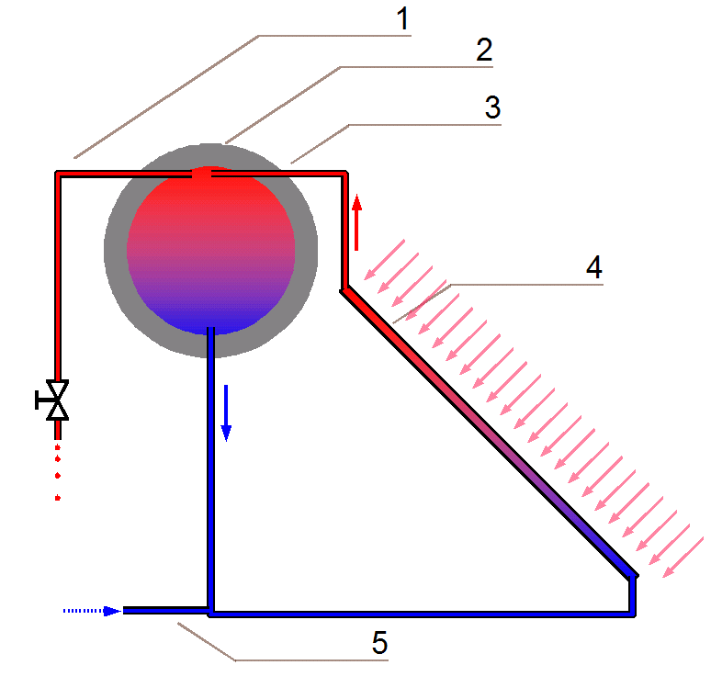

(Wikipedia, n.d.)

****Refrigerator****

* At the top of the fridge the liquid fluid passes through an expansion valve and evaporates, absorbing the latent heat of vapourisation and cooling the fridge
* The cooling of the air at the top of the fridge establishes convection currents that cool the whole fridge
* Outside the fridge the gas is compressed to make a hot gas, this is passed through the condenser, releasing the latent heat of vapourisation as it becomes a liquid
* The net result is that heat is moved from inside the fridge to outside the fridge

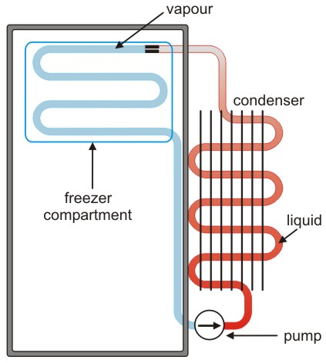

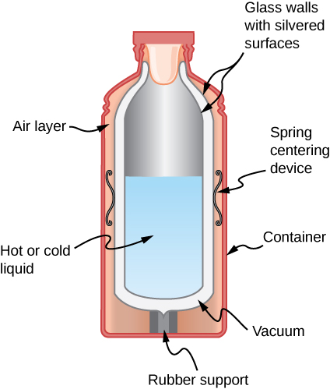

(The Open Door Website, n.d.)(DoucNic, 2018)(LibreTexts, n.d.)

****Vacuum flask****

* Core device is made of 2 layers of silvered glass with a vacuum between the layers
* Glass is a poor conductor
* conduction and convection can’t occur through the vacuum
* The silvering minimises transfer of heat by radiation
* Very minimal heat flow into or out of the flask

****Houses****

* Often advantageous to block heat transfer into/out of a home
* Most methods trap pockets of air which is a poor conductor and can’t convect when trapped
* Double glazed windows
* Ceiling batts
* Wall cavity insulation

**Heat Revision for Topic Test.**

Revise all heat STAWA sets and Pearson chapter reviews.

1. Distinguish between the terms:
2. heat
3. Internal energy
4. Temperature
5. A student asked, “How much heat is possessed by that piece of lead?” Is this possible? Explain.
6. A solar panel heats 20 kg of water of water at an initial temperature of 20.50C. if the solar panel absorbs 850 J/s, determine the temperature of the water 2 hours later.
7. A paddle wheel is used to stir 250 mL of water in a beaker. The wheel is turned by a 12.5 kg mass falling vertically 120cm. The temperature rose by 3.0 0C after letting the weight drop 30 times.
8. Determine the SHC of the water.
9. Determine the percentage error for the SHC.
10. Explain why the water got warmer, referring to the particle model.
11. Convert the following;

|  |  |  |  |  |  |
| --- | --- | --- | --- | --- | --- |
| Temp (0C) | 30 | -173 |  |  |  |
| Temp (K) |  |  | 0 | 373 | 60 |

1. 100 g of lead shot heated to 120 0C was placed in 150 ml of water at 25.0 0C, the mixture rose by 2.15 0C. Determine the SHC of lead.
2. 30.0 g of crushed ice is added into 450 g of water at 60.00C. Find the final temperature after the ice has melted.
3. Why is it wise to wear white in summer and in winter to remain comfortable?
4. Explain why lakes don’t freeze over in Winter when the temperature drops to -300C.
5. Why are motorcycle engines painted black? Explain
6. How do silver space blankets help a) frozen people b) athletics after an exhausting run?
7. Why do tramps stuff their clothing with paper to keep warm?
8. Why does a block of wood feel warm whereas a block of steel in same room feels cold?
9. How does the human body maintain its body temperature? How do humans help their body maintain their body temperature?
10. Explain how a thermos flask, refrigerator, reverse cycle and evaporative airconditioning and solar heater work.
11. A 500 W heater heats up 150 mL of ice at 00C over a 10 minute period. Draw the temp vs time graph to show what will occur.
12. Using the kinetic theory explain the following:
13. An aerosol can explodes in a fire
14. Perfume can be smelt on the other side of the room.
15. Steam condenses.
16. Determine the rise in temperature of a steel drum (5.00kg) containing 450kg of water, if the drum receives 160 MJ of energy when placed over an open fire.
17. In order to cool down a piece of silver (mass 50.0g) that is heated to 180 0C, a jeweler places it in 100 mL of water at 20.00C. The temperature of the water rises to 24.50C. Determine the specific heat capacity of the silver. Is it pure silver?
18. A student takes the following measurements in order to determine the amount of energy imparted by a Bunsen burner:

|  |  |  |  |  |
| --- | --- | --- | --- | --- |
| Initial temp of water (0C) | Final temp of water (0C) | Mass of water  (g) | Fineness of scale (0C) | Fineness of scale (g) |
| 25.0 | 83.5 | 556 | 0.1 | 0.01 |

* 1. Determine the amount of energy received by the water.
  2. Determine the % uncertainty of your answer, if the % uncertainty of the specific heat capacity of water is 0.01%.
  3. Determine the power of the Bunsen burner if it took 5 minutes for the heating process.
  4. If the Bunsen burner is rated at 500 W, determine the percentage error in your answer.

****References****

DoucNic. (2018, October 25). *Community Energy Systems*. Retrieved from Geothermal Heat Pumps For Water Heaters And Refrigerators – Well maybe but it is expensive: https://censys.org/blog/?p=597

*LibreTexts*. (n.d.). Retrieved from Mechanisms of Heat Transfer: https://phys.libretexts.org/TextMaps/General_Physics_TextMaps/Map%3A_University_Physics_(OpenStax)/Map%3A_University_Physics_II_(OpenStax)/1%3A_Temperature_and_Heat/1.6%3A_Mechanisms_of_Heat_Transfer

*The Open Door Website*. (n.d.). Retrieved from Thermal Physics: http://www.saburchill.com/physics/chapters/0126.html

*Thermometer Clip Art - Image #8708*. (n.d.). Retrieved from Clip art: http://cliparting.com/free-thermometer-clip-art-8708/

*Wikipedia*. (n.d.). Retrieved from https://upload.wikimedia.org/wikipedia/commons/d/d4/Thermosiphon2.png